Date | Posts | Visual Assets
APR 1  Post 1: | It’s PREVENTION MONTH!  This April join New Hampshire’s many family serving partners in celebrating all the ways we can support children and their caregivers.  PREVENTION IS POSSIBLE and takes each and every one of us, working together, to make sure Granite State parents are resilient and have access to family supports.  See how we support families by visiting our website at www.nhchildrenstrust.org  #PreventionIs #momlife #fatherhood #dad #mom #parenting #parentalresources #strongfamilies #preventchildabuse #BePrevention #IAmPrevention #ThrivingFamilies  #StrengtheningFamilies | Month Celebration tile  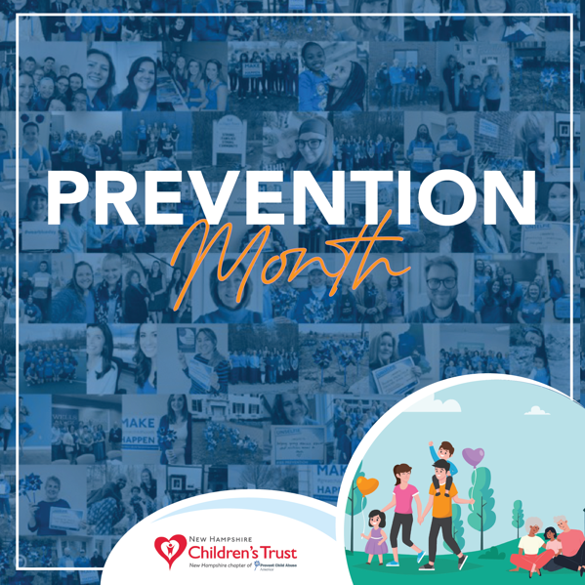  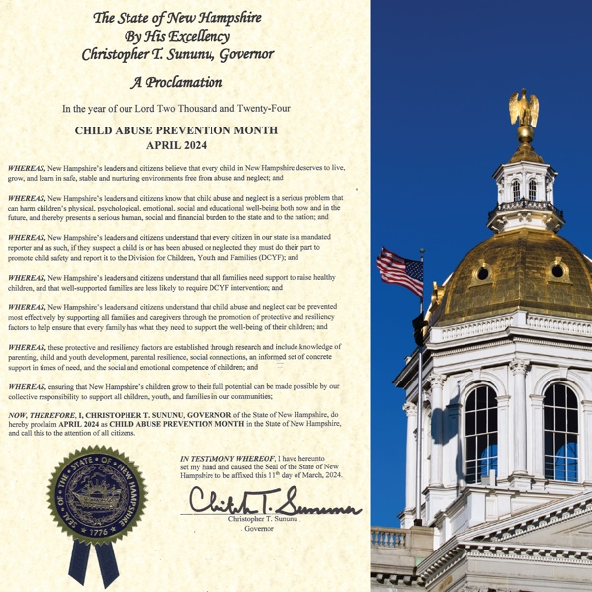
APR 3  Post 1: | When we use upstream thinking—before challenges occur—to help Granite State families, all of New Hampshire succeeds!  It’s about making sure families have what they need for good things to happen—family strength and resilience, a child regulating their emotions, parents positively interacting with the children in their care, and family joy.  ​  Because when families are strong and supported, WE ALL BENEFIT.  Build your family strengthening ecosystem by contacting your local FAMILY RESOURCE CENTER.  #PreventionIs #momlife #fatherhood #dad #mom #parenting #parentalresources #strongfamilies #preventchildabuse #BePrevention #IAmPrevention #ThrivingFamilies  #StrengtheningFamilies | Question Tile: What is Family Strength?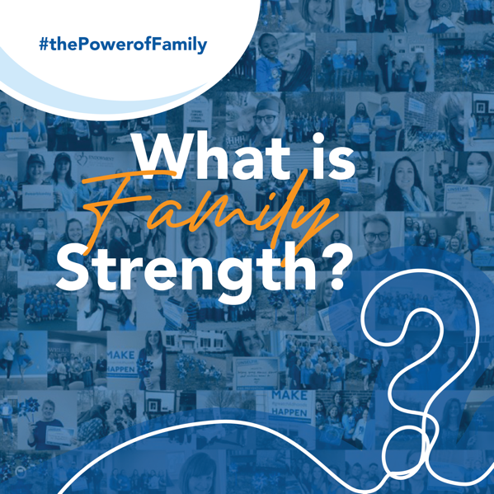
Post 2: | Did you know solutions exist to challenges facing Granite State families?  The Family Support Data System reports that the majority of families visiting NH’s network of Family Resource Centers are single-mother lead households. We also know, women in NH earn 82 cents of every dollar earned by men. For women of color, that gap is even wider.  You want strong families? EQUAL PAY = FAMILY STRENGTH.  Help New Hampshire think upstream by sharing this post!  Visit nhwomensfoundation.org to learn more.  #PreventionIs #momlife #fatherhood #dad #mom #parenting #parentalresources #strongfamilies #preventchildabuse #BePrevention #IAmPrevention #ThrivingFamilies  #StrengtheningFamilies | DID YOU KNOW tile: Transforming the Narrative 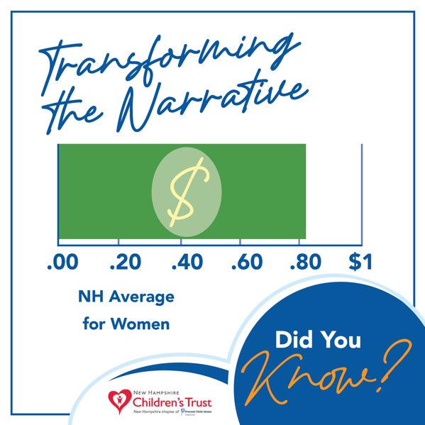
APR 5  Post: 1  WEAR BLUE DAY | IT’S WEAR BLUE DAY!  Help us celebrate by dressing in BLUE!  Because FAMILY is New Hampshire’s BEST INVESTMENT!  #PreventionIs #momlife #fatherhood #dad #mom #parenting #parentalresources #strongfamilies #preventchildabuse #BePrevention #IAmPrevention #ThrivingFamilies  #StrengtheningFamilies | Wear Blue day tile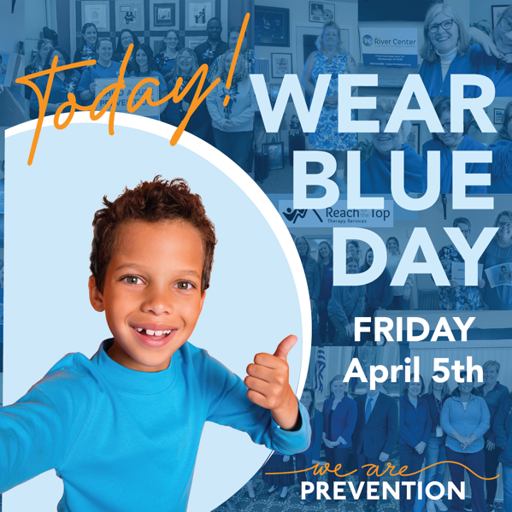
APR 6  Post 1: | HELP US celebrate the Week of the Young Child  with Brain Building Basics from VROOM!  Visit tinyurl.com/Brain-Building-Basics  -Look  -Chat  -Follow  -Take Turns  -Stretch  Learn all about VROOM at vroom.org  #PreventionIs #momlife #fatherhood #dad #mom #parenting #parentalresources #strongfamilies #preventchildabuse #BePrevention #IAmPrevention #ThrivingFamilies  #StrengtheningFamilies | Family Fun Day Tile! VROOM!  https://www.vroom.org/  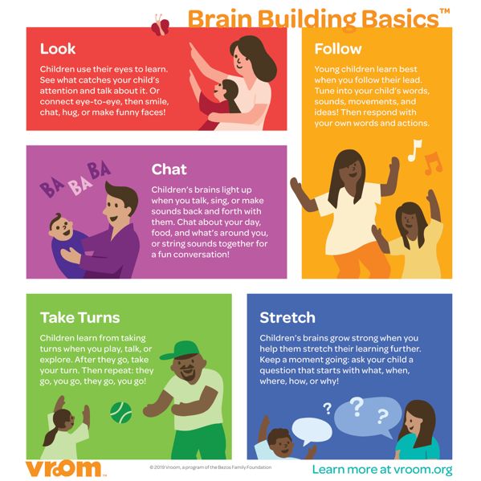
APR 8  Post 1: | When children and their caregivers have access to learning opportunities, they develop foundational life skills that become part of family strength.  And the BEST PART: those strengths are passed generation to generation creating stability and economic mobility.  FAMILY is New Hampshire’s BEST INVESTMENT  Pass it on!  #PreventionIs #momlife #fatherhood #dad #mom #parenting #parentalresources #strongfamilies #preventchildabuse #BePrevention #IAmPrevention #ThrivingFamilies  #StrengtheningFamilies | Aspirations Tile: Foundational Life Skills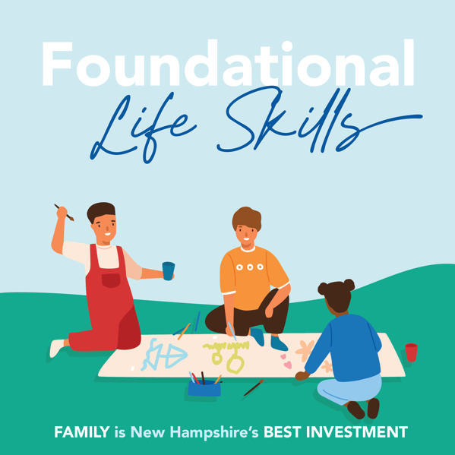
APR 10  Post 1: | Investing in family support creates the conditions where parents are able to avoid or limit financial hardships. When families are financially stable, they have greater economic mobility. AND when families are economically mobile, all of New Hampshire succeeds.  Family financial stability = Granite State Success  PASS IT ON!  #PreventionIs #momlife #fatherhood #dad #mom #parenting #parentalresources #strongfamilies #preventchildabuse #BePrevention #IAmPrevention #ThrivingFamilies  #StrengtheningFamilies | Question Tile: Why Primary Prevention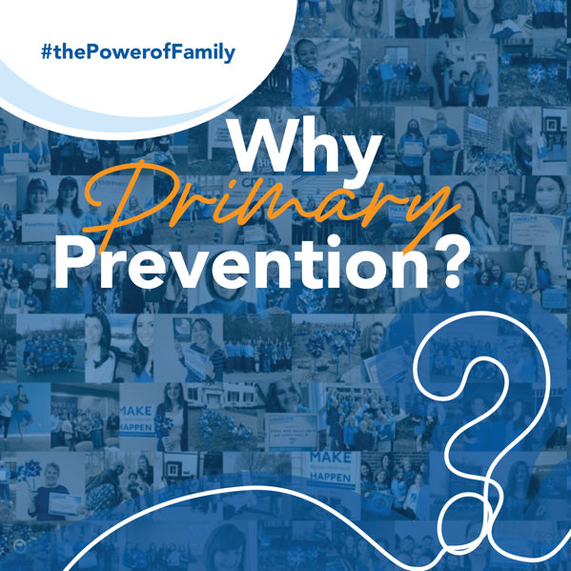
APR 12  Post 1: | Designing communities for family success means making sure they have access to the supports we know work. Supports like NH Childcare Scholarship, SNAP and WIC, medical benefits, legal, and in some cases direct payment.  And that means we also must invest in organizations like FAMILY RESOURCE CENTERs who are NH’s hubs of family support.  FAMILY is New Hampshire’s BEST INVESTMENT  #PreventionIs #momlife #fatherhood #dad #mom #parenting #parentalresources #strongfamilies #preventchildabuse #BePrevention #IAmPrevention #ThrivingFamilies  #StrengtheningFamilies | Structures Tile: Access 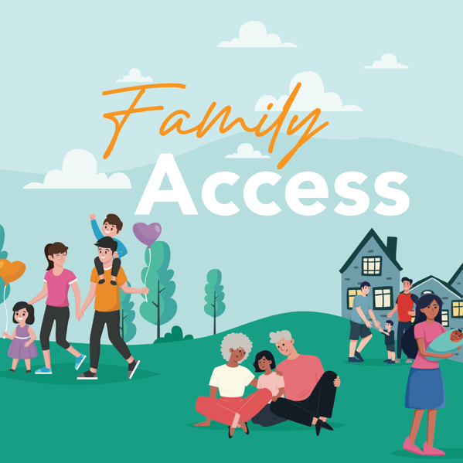
APR 13  Post 1: VROOM TOOL | Get Ready for some AT-HOME TIPS brought to you by VROOM!  Share them, put them up on your fridge, or carry them around—whatever helps remind you that brain-building moments are all around you.  Visit tinyurl.com/At-Home-Tips  Learn all about VROOM at vroom.org  #PreventionIs #momlife #fatherhood #dad #mom #parenting #parentalresources #strongfamilies #preventchildabuse #BePrevention #IAmPrevention #ThrivingFamilies  #StrengtheningFamilies | Family Fun Day Tile! VROOM!  https://www.vroom.org/
APR 15  Post 1: | The key to life-long wellbeing begins at birth. During the first three-years of life, our brains are built 1 million neural connections per second, which means we set up for future success when we invest in supports for child (and their caregivers) that target the 1000 days of life.  FAMILY is New Hampshire’s BEST INVESTMENT  See what programming we have available for young child: www.nhchildrenstrust.org  #PreventionIs #momlife #fatherhood #dad #mom #parenting #parentalresources #strongfamilies #preventchildabuse #BePrevention #IAmPrevention #ThrivingFamilies  #StrengtheningFamilies | Aspirations Tile: Well-being 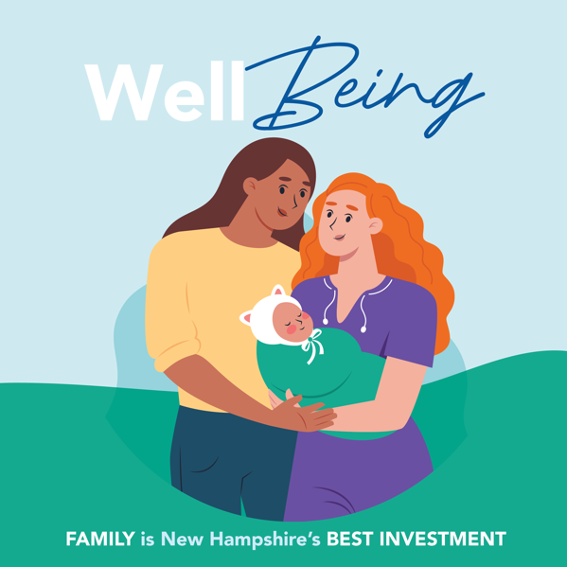
APR 17  Post 1: | DID YOU KNOW that centering families in the services and systems they use every day creates more efficient, equitable, and impactful service delivery?  Human-centered design is an opportunity building technique that puts real people (and families) at the center of service and systems creation. When we prioritize family insights and experiences, we advance primary prevention solutions that meet all New Hampshire’s unique needs and aspirations.  The result? Services and system THAT WORK.  Visit us today to learn more about our family-centered programs and services: www.nhchildrenstrust.org  #PreventionIs #momlife #fatherhood #dad #mom #parenting #parentalresources #strongfamilies #preventchildabuse #BePrevention #IAmPrevention #ThrivingFamilies  #StrengtheningFamilies | DID YOU KNOW Tile: Center Families 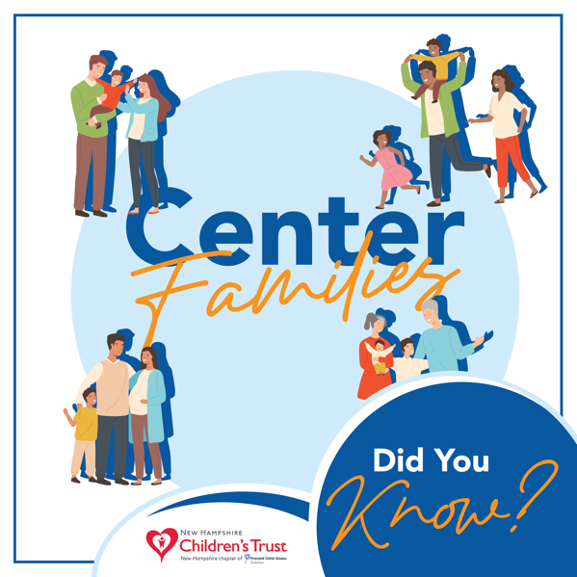
APR 19  Post 1: | The saying is “When you’ve visited one family resource center you visited one family resource center.”  Why? Because their uniqueness helps them meet the unique needs of families in their communities.  FIND your FAMILY RESOURCE CENTER today by using the FRC locator at the bottom of FSNH.org.  #PreventionIs #momlife #fatherhood #dad #mom #parenting #parentalresources #strongfamilies #preventchildabuse #BePrevention #IAmPrevention #ThrivingFamilies  #StrengtheningFamilies | Family Support FRIDAY! With all the FRC logos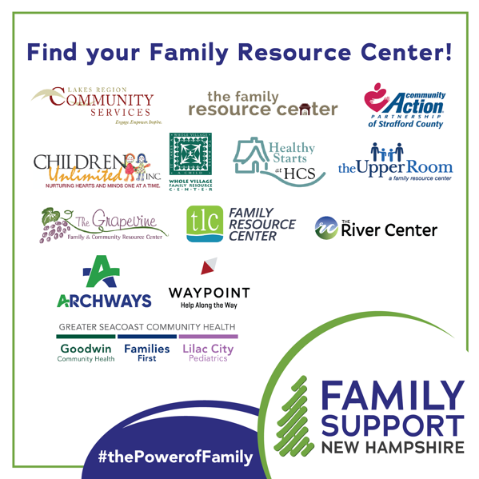
APR 20  Post 1: Get to Know your Local FRC | VROOM can also help parents and caregivers with CHALLENGING MOMENTS!  Click on the link to find strategies and also build foundational life skills: tinyurl.com/0-to-5-Challenging-Moments  Learn all about VROOM at vroom.org  #PreventionIs #momlife #fatherhood #dad #mom #parenting #parentalresources #strongfamilies #preventchildabuse #BePrevention #IAmPrevention #ThrivingFamilies  #StrengtheningFamilies | Family Fun Day Tile! VROOM!  https://www.vroom.org/
APR 22  Post 1: | Resilience is more than a buzzword. It’s a positive personality characteristic that enhances individual adaptation, specifically the ability to identify what is stressful, realistically appraise one’s capacity for action, and problem solve effectively.  And there’s even a scale to measure it!  The good news is personal and family resilience is like a muscle: the more you use it, the big and strong it gets.  Creating a healthy ecosystem in which families thrive requires that we are intention about resilience building. That means investing in parenting groups, kinship care supports, social and emotion learning, and upward economic mobility.  FAMILY is New Hampshire’s BEST INVESTMENT  #PreventionIs #momlife #fatherhood #dad #mom #parenting #parentalresources #strongfamilies #preventchildabuse #BePrevention #IAmPrevention #ThrivingFamilies  #StrengtheningFamilies | Aspirations Tile: Resilience 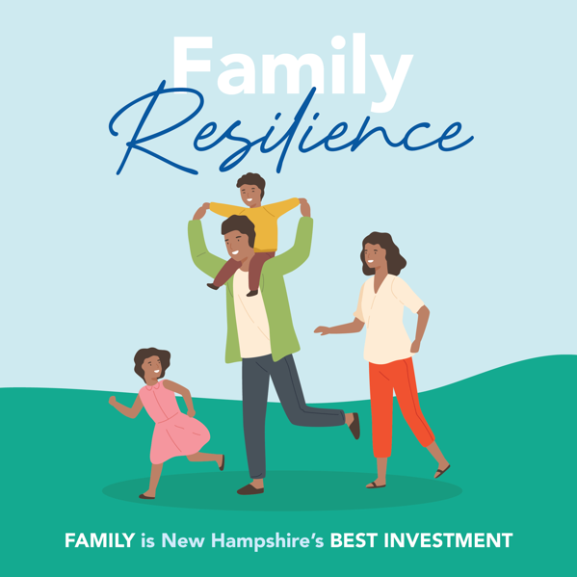
APR 23  Post 1: | When thinking up-stream to prevent a problem from ever occurring, we must first agree that the problem one that we’d like to solve (like child poverty) AND that the those impacted (child and families) HAVE VALUE.  Primary Prevention is having SHARED VALUES.  Tell us how you value child and families in the comments below.  #PreventionIs #momlife #fatherhood #dad #mom #parenting #parentalresources #strongfamilies #preventchildabuse #BePrevention #IAmPrevention #ThrivingFamilies  #StrengtheningFamilies | Question Tile: How is Prevention made possible?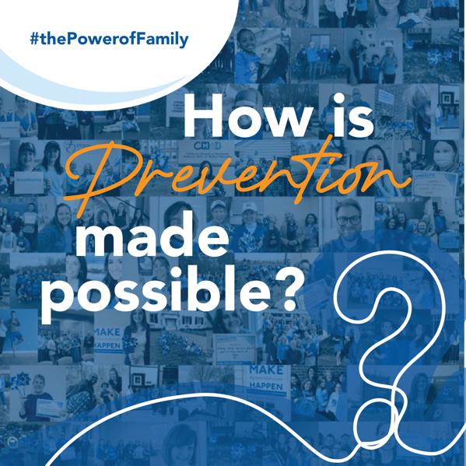
APR 24  Post 1: | WHAT WE KNOW: Kinship Care  96% of NH children being raised by relatives are OUTSIDE the foster care system. AND nearly 50% of families in the Kinship Navigation Program report difficulty affording monthly expenses because of expenses related to kinship caregiving.  AND relationships with grandparent caregivers can lead to improved caregiver and child mental health AND Children in kinship care fare better on standardized tests than children in non-relative foster care.  SUPPORTING Kinship Caregivers = STRONGER NH  #PreventionIs #momlife #fatherhood #dad #mom #parenting #parentalresources #strongfamilies #preventchildabuse #BePrevention #IAmPrevention #ThrivingFamilies  #StrengtheningFamilies | DATA Tile: Building Evidence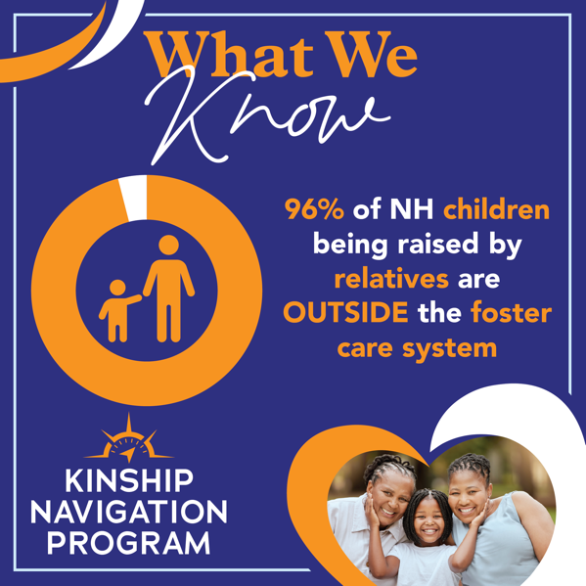
APR 25  Post 1: | KNOWLEDGE is prevention.  Are there any PARENTING STRATEGIES that help your family?  Let us know in the comments below!  #PreventionIs #momlife #fatherhood #dad #mom #parenting #parentalresources #strongfamilies #preventchildabuse #BePrevention #IAmPrevention #ThrivingFamilies  #StrengtheningFamilies | KNOWLEDGE Protective Factors: Feature Tile with the a Frame of the Video
Post 2: | Parents and caregiver are experts in their own experience. Whether it’s navigating child care, school, caretaking an older adult—they understand their families’ needs and what obstacles may come between them and success.  What better resource than families for decision-making that affects the family unit?  Engaging diverse families as partners provides rapid feedback for solutions that impact us all.  FAMILY is New Hampshire’s BEST INVESTIMENT  #PreventionIs #momlife #fatherhood #dad #mom #parenting #parentalresources #strongfamilies #preventchildabuse #BePrevention #IAmPrevention #ThrivingFamilies  #StrengtheningFamilies | Structures Tile: Decision Making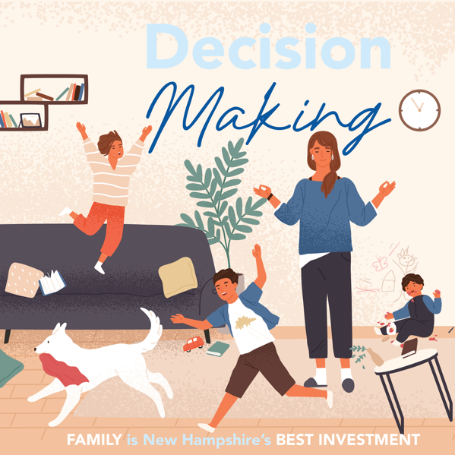
APR 26  Post 1: | Get to know YOUR LOCAL FAMILY RESOURCE CENTER!  FRCs server 97% percent of New Hampshire towns and cities and they provide free, confidential and voluntary services that help families lean into the strengths they already have.  Visit us at www.fsnh.org to learn more about the family-strengthening programs we offer!  #PreventionIs #momlife #fatherhood #dad #mom #parenting #parentalresources #strongfamilies #preventchildabuse #BePrevention #IAmPrevention #ThrivingFamilies  #StrengtheningFamilies | Family Support FRIDAY! 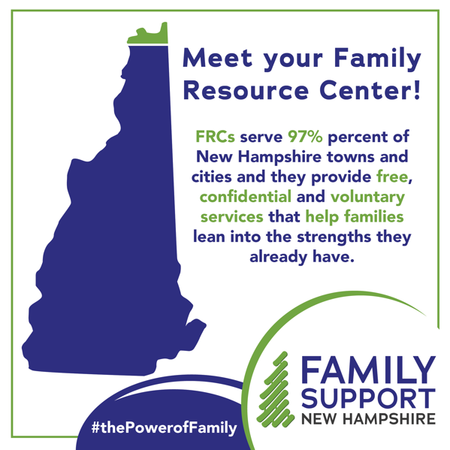
APR 27  Post 1: | All parents and caregivers face TIMES of STRESS. The great thing about parenting strategies is they can refocus the child (and caregiver) on small but significant change that positively affect the daily routine.  Click on the link to a few stress reducing strategies that also encourage brain development of our young ones: tinyurl.com/Stressful-Times  Learn all about VROOM at vroom.org  #PreventionIs #momlife #fatherhood #dad #mom #parenting #parentalresources #strongfamilies #preventchildabuse #BePrevention #IAmPrevention #ThrivingFamilies  #StrengtheningFamilies | Family Fun Day Tile! VROOM!  https://www.vroom.org/
APR 28  Post 1: | The link between social connection and health outcomes is a clear as day.  Research shows that socially connected individual lead longer lives, they experience better physical and mental health, and overall well-being.  And what better an opportunity than to connect with a new parent or caregiver who are more likely to experiences social isolation and perinatal depression.  I am Prevention. You are prevention. WE ARE PREVENTION.  #PreventionIs #momlife #fatherhood #dad #mom #parenting #parentalresources #strongfamilies #preventchildabuse #BePrevention #IAmPrevention #ThrivingFamilies  #StrengtheningFamilies | Aspirations Tile: Mental and Physical Health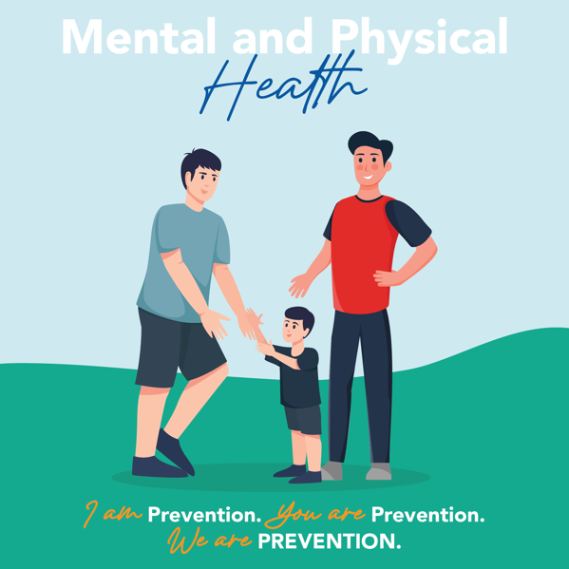
APR 30  Post 1: | THANK YOU to all our PARTNERS in FAMILY SUPPORT  Strengthening Families is the process of meeting our families where there at and thinking upstream to design human-center solutions that work.  To learn more about all that we do in support of Granite State Families, visit www.nhchildrenstrust.org  #PreventionIs #momlife #fatherhood #dad #mom #parenting #parentalresources #strongfamilies #preventchildabuse #BePrevention #IAmPrevention #ThrivingFamilies  #StrengtheningFamilies | Question Tile: WHEN is Prevention made possible?